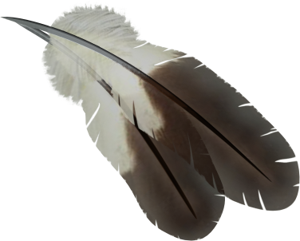
JOM/Title VI

Johnson O’Malley (JOM) is a program for all American Indian students that are enrolled in a federally recognized Tribe.
Title VI is a program for all American Indian students enrolled in a Tribe or who are a first or second generation descendent. A descendent is a person that is not enrolled in a Tribe, but their grandfather, grandmother, father or mother is an enrolled member.
Omak School District receives funds to provide these students support beyond basic education. The following staff works to meet the needs of the students in their buildings:

Leslie Edwards North Elementary
Amber Barnaby East Elementary
Pamela Edmonds Middle School
April Bigelow High School

These programs offer consultation and tutoring to American Indian students. Our goal is to provide the opportunity for every student to succeed.
The JOM/Title VI Parent Advisory Committee (PAC) meets every other month to oversee both programs and approve the direction of the school district regarding the program.
All parents are welcome and encouraged to attend the meetings.

